# Introduction

BigU[1] is a state land grant University. With more than 30,000 students and more than 4,000 employees, it has extensive programs including education, research, and extension missions. Its annual budget easily exceeds a billion dollars. BigU’s operations are highly dependent on computer technology and applications so cyberthreats are an ongoing concern. BigU’s IT operations are diverse and only partly centralized. Perhaps the most important (and inherently risk-laden) application is its Enterprise Resource Planning (ERP)[2] application with its related sub-systems. BigU’s financial operations (including, but not limited to student records) are managed in the system. An IT audit for BigU would focus first on assuring that reasonable controls are in place to ensure that its ERP will help BigU meet its objectives.

The ERP system was recently redeployed from on premises operation to a cloud provider in a Platform as a Service (PaaS) configuration. The BigU IT eco-system is multi-faceted but the ERP databases, web access, and middleware are run on infrastructure from a cloud provider[3]. Identity infrastructure is hosted by Microsoft. And, as is to be expected, various processes and network interconnections are also in place to connect the cloud system to other BigU applications and operations.

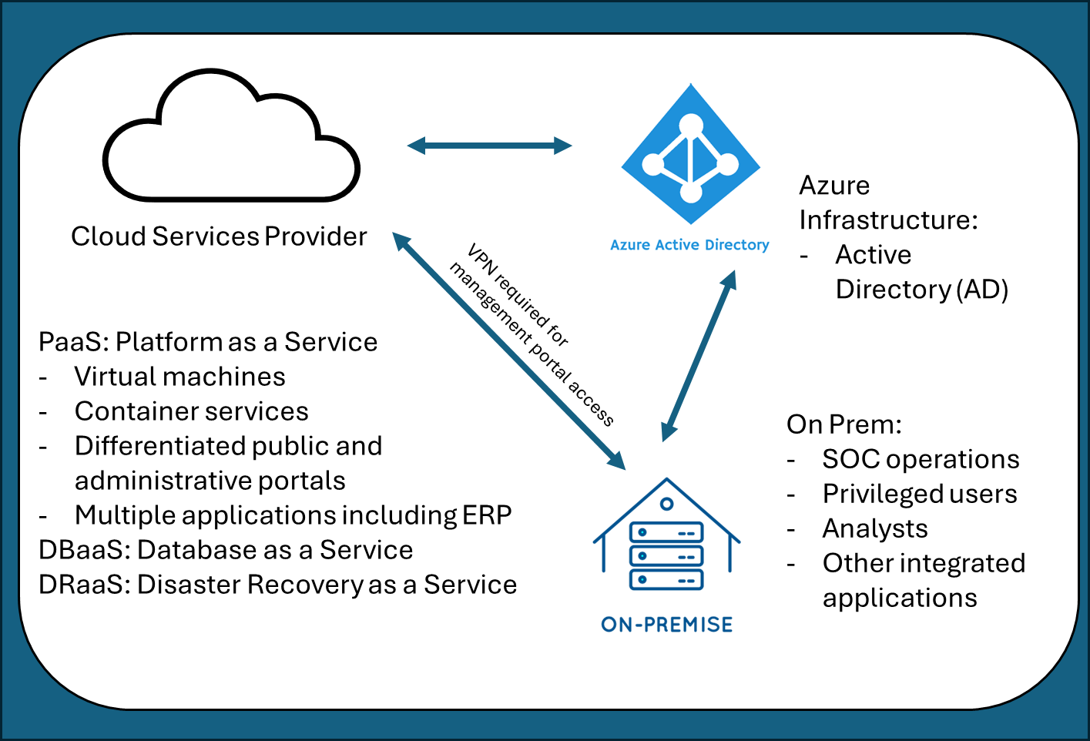

BigU manages a number of other important systems and services including laptops and workstations, computer labs, printers, facilities management systems, other application-specific programs and systems, and productivity tools such as email, word processing, spreadsheets and more. Taken together, risks in these systems are substantial. A wide variety of processes are needed to protect these systems from compromise or disruption.

1. BIGU was inspired by Oregon State University (OSU) but numerous details are altered to protect confidential information and to help illustrate class concepts. Many thanks to OSU professionals who helped prepare this case.
2. We considered how Ellucian’s Banner works to help formulate this case, but the case’s ERP system details have been altered to illustrate concepts, respect non-disclosure limits, and avoid potential real-world security implications.
3. While OSU is using Oracle for cloud services, and some exercises employ publicly available documentation of Oracle services, details related to both OSU’s use and Oracle’s offerings have been adapted for illustration.